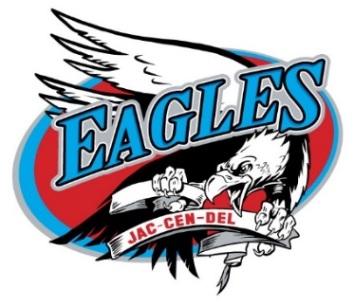

www.jaccendel.k12.in.us

Central Office High School / Athletics Elementary School
723 N Buckeye Street 4586 N US 421 4544 N US 421
Osgood, Indiana 47037 Osgood, Indiana 47037 Osgood, Indiana 47037
Telephone: (812) 689-4114 Telephone: (812) 689-4643 Telephone: (812) 689-4144
Fax: (812) 689-7423 Fax: (812) 689-5632 Fax: (812) 689-5909

Every Child Every Chance Every Day

Jac-Cen-Del Community Schools

June 2, 2022

The Jac-Cen-Del Athletic Department will be hosting the 26th Annual Eagle Classic Golf Tournament on August 20, 2022 at 8:00 am at the North Branch Golf Course in New Point, Indiana. The funds from this tournament help purchase uniforms, supplies, equipment, and transportation for the JCD sports teams. You have been a generous supporter of the Eagle Classic in the past and we are once again asking for your support to make this year’s event another success.

Over the years the Classic has become more than just a fundraiser. It has become a huge reunion where JCD friends and alumni meet to reconnect and enjoy a friendly day of golf. Last year was a record breaking year as we hosted 42 teams. Sponsorship is a great way to show your business’ support and advertise to a large group at the same time. Hole sponsorships are $100 and include a custom sign on the tee bed or green. All sponsorship, at any level, is recognized after the luncheon and later in a newspaper ad. We welcome any help you may give including cash or door prizes.

We have included a form below to make it easier for you to reply. Please respond by Friday, August 5, 2022. Thanks in advance for your continued support of Jac-Cen-Del Athletics and we hope to see you at the Classic!

Sincerely,

JCD Athletics

________________________________________________________________________

Yes! I want to help support JCD Athletics. Checks payable to JCD Athletics

Please return to: $250_____ $100_____ $50_____ $25_____ Door Prize_____
Corporate Hole
Sponsor Sponsor
JCD Athletics
4586 N US Hwy 421
Osgood, IN 47037

If you would like someone from the school to stop by your business & pick-up your donation, please check here_____

If you would like to put in a golf team, please reach out to us at bmerkel@jaccendel.k12.in.us or 812.689.4643 ext. 2225. Cost per team is $200.00

