2021 North Decatur – Varsity Boys Track
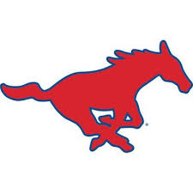
Name | Cell Phone Number | Attendance  M 4/5 | T 4/6 | W 4/7  Rushville | Th 4/8 | F 4/9  TC invite
Kaleb Phelps |  | NO PRACTICE
Jordan Redelman
Austin Schwartz
James Evans
Jake Kinker
Mason Dimett
Cole Stephen
Martin Azloaga
Mason Burkhart
Josh Evans
Noah Howell
Andrew Tielking
Charlie Kramer
Conner Linkmeyer
Kaden Muckerheide
Kaiden Gahimer
Logan Koehne
Evan Howell
Cole Theobold
Ellis Loehmer
Ryan Hancock
Owen Geis
Ethan Wood

