ONE BULLDOG BLVD 812.934.5175 ext. 13202 agarrett@batesville.k12.in.us
BATESVILLE, IN 47006 812.528.6683 (cell) www.batesvillebasketball.com

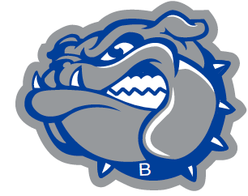 BATESVILLE BASKETBALL

Conference Championships: 63,70,71,75,77,79,81,82,83,88, Varsity Coach: Aaron A. Garrett
94,95,96,97,03,06,07,08 Associate Head Coach: Andy Allen Sectional Championships: 27,33,3440,41,44,43,45,49,50,51, Varsity Assistant: Blaine Gellert 52,63,71,74,76,79,83,89,94,95,96,97,00,01,02,06,07,08,11,19 Junior Varsity: Jay Gerkin
Regional Championships: 34,43,51,52,71,94,01,07,08,11 Freshman: Scott Henderson
Semi-State Championships: 43,01 Eighth Grade: Tyler Burcham
Seventh Grade: Garrett Burkhart

Alumni Game
Information

Please complete the following information even if you cannot attend the games on November 29. My goal is to have contact information for all of the former players.
Feel free to email your response to me: agarrett@batesville.k12.in.us

Name: ________________________________________

Year of Graduation: __________________

Address: _______________________________________________________________

Home Phone: ___________________ Cell Phone: ___________________

T-SHIRT SIZE: ___________
*If you plan on attending the game but not playing, I still want to get you a shirt.

Email address: __________________________________________________________
*let me know if there is another email address you would like to add to my distribution list
_______ Yes, I would like to play in the Alumni game.

_______ NO, I will not be playing in the Alumni game.

Will you be in attendance for Alumni Game?

________ YES ________NO

If you know of a fan of the program that wants to be added to my email database, please write their name and email address below:

