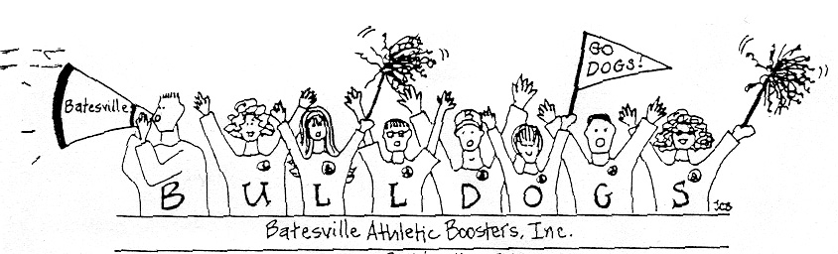

Dear Batesville Athletic Supporter:

The Batesville Athletic Booster Club will be hosting the Annual Fall Raffle at the Batesville Knights of Columbus on Wednesday, September 18 at 6:00 p.m. It is your Bulldog pride and support of this fundraiser that has enabled us to purchase uniforms and safety equipment for our athletes.

Once again, we are asking each of you to support this very important project by purchasing an Athletic Booster’s Dinner / Raffle ticket for only $20.00 advance sale. Tickets orders postmarked after September 11th or at the door will be $25.00. Each ticket is good for a chicken dinner, refreshments, and a chance to win one of many prizes. First prize is $2,000! You will get your $20 worth just from the meal alone. This is an adult only affair, but carryouts are available. You do not have to be present to win a prize.

Doors Open 5:45 pm
Drinks served 5:45 pm
Carry-outs 6:00 pm
Meal 6:00 pm
Prizes drawn 7:00 pm

Please complete & return the order form below with payment and your reservation will be made. Please provide your email address & we will email you a confirmation. On Wednesday the 18th, just check in before eating. Your name will be on the list of supporters.

Thank you in advance for your support of the Batesville Athletes. Best wishes for your athlete's success on and off the field or court in the 2019-2020 year.

Sincerely,
Bertha Hazelwood, President
Wendy Meyer, Committee Chair
------------------------------------------------------------------------------------------------------------
TO PURCHASE A DINNER/RAFFLE TICKET…
Please complete all information.

_______ Number of Tickets at $20 each ticket ($25 after Sept 11th)
Make Checks Payable to Batesville Athletic Boosters

$________ Total enclosed

Name(s) on Tickets __________________________________________________________

____________________________________ _______________________________________
Address for ticket Phone number for ticket

Email address: ________________________________________________________________

Please Complete and mail to address below by September 11

Batesville Athletic Boosters
PO Box 274
Batesville, IN 47006ic

